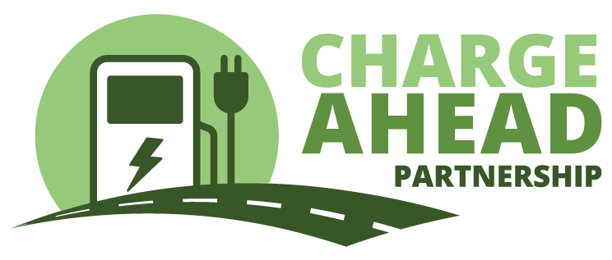Contact: Ryan McKinnon

703-772-0123

June 17, 2024

**Mississippi has still not opened up applications for $50.5 million in federal electric vehicle charging funds**

**-- While chargers are opening or underway in other states, Mississippi has still not released an application for potential grant recipients --**

Mississippi has still not released an application for electric vehicle charging operators to access millions of dollars in National Electric Vehicle Instructure (NEVI) funding. While other states are celebrating the opening of the first NEVI chargers, the businesses along Mississippi’s interstates still can’t apply to participate in this program, which is part of the 2021 Bipartisan Infrastructure Law.

Charge Ahead Partnership, a coalition of businesses working to expand the nation’s EV charging network through free-market competition and private investment, encourages the state to open up applications so that private businesses can expand their investment in EV charging through this grant-matching program.

The NEVI Program authorized the federal government to distribute $5 billion to states to provide grant funding for businesses that want to offer EV charging. Mississippi is set to receive $50.5 million over five years.

Mississippi is one of just 16 states that has still not issued an application for EV charging providers hoping to receive a grant. Much of the media coverage about the NEVI program has highlighted how slowly this program is rolling out, but the federal government has approved Mississippi’s plan and now the state is responsible for getting the grants into the hands of EV charging operators.

“The gas stations and travel plazas that line Mississippi’s interstates are natural spots for EV charging stations, if only these businesses could access this grant funding to help with the initial costs of offering this service,” said Charge Ahead Partnership executive director Jay Smith. “The federal NEVI funds can be a great help, but the state has not even created an opportunity for businesses to apply for a grant.”

NEVI is a grant-matching program, designed to spark investment in EV charging infrastructure by assisting with the start-up costs for buying and installing high-speed EV chargers at strategic locations along each state’s major highways. The vast majority of funds deployed by other states have gone to private enterprise, allowing small businesses and national chains to add EV charging to the services they provide to customers.

The sluggish deployment of NEVI in Mississippi slows the growth of the EV charging private marketplace and increases the chances that captive utility ratepayers will be stuck paying for power-company owned and operated charging networks.

“Mississippi is wasting the opportunity to deploy millions of dollars in federal grants to small businesses within the state,” Smith said. “We urge the state to get moving on opening up an application so that NEVI can get started in Mississippi.”

###

To learn more about **Charge Ahead Partnership (CAP)** and join our efforts to help expand America’s EV charging network please visit [**www.chargeaheadpartnership.com**](http://www.chargeaheadpartnership.com/). In addition to joining CAP you can stay connected with us by following us on social media on Twitter at [**@EV_ChargeAhead**](https://twitter.com/EV_ChargeAhead), Facebook at [**@ChargeAheadPartnership**](https://www.facebook.com/ChargeAheadPartnership) and on Instagram at [**@EVChargeAhead**](https://www.instagram.com/EVChargeAhead/).