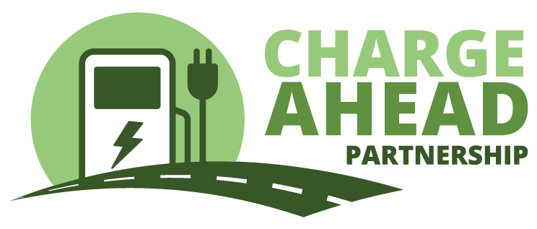Contact: Ryan McKinnon

703-772-0123

June 17, 2024

**South Carolina has still not opened up applications for $70 million in federal electric vehicle charging funds**

**-- While chargers are opening or underway in other states, South Carolina has still not released an application for potential grant recipients --**

South Carolina has still not released an application for electric vehicle charging operators to access millions of dollars in National Electric Vehicle Instructure (NEVI) funding. While other states are celebrating the opening of the first NEVI chargers, the businesses along South Carolina’s interstates still can’t apply to participate in this program, which is part of the 2021 Bipartisan Infrastructure Law.

Charge Ahead Partnership, a coalition of businesses working to expand the nation’s EV charging network through free-market competition and private investment, encourages the state to open up applications so that private businesses can expand their investment in EV charging through this grant-matching program.

The NEVI Program authorized the federal government to distribute $5 billion to states to provide grant funding for businesses that want to offer EV charging. South Carolina is set to receive a total of $70 million over five years.

South Carolina is one of just 16 states that has still not issued an application for EV charging providers hoping to receive a grant. Much of the media coverage about the NEVI program has highlighted how slowly this program is rolling out, but the federal government has approved South Carolina’s plan and now the state is responsible for getting the grants into the hands of EV charging operators.

“South Carolina has countless businesses that would be ideal for offering high-speed EV charging,” said Charge Ahead Partnership executive director Jay Smith. “But instead of getting these grants into the hands of small business owners, the state has not even issued an application for funds.”

NEVI is a grant-matching program, designed to spark investment in EV charging infrastructure by offsetting the start-up costs for buying and installing high-speed EV chargers at strategic locations along each state’s major highways. The vast majority of funds deployed by other states have gone to private enterprise, allowing small businesses and national chains to add EV charging to the services they provide to customers.

The sluggish deployment of NEVI in South Carolina slows the growth of the EV charging private marketplace and increases the need for captive utility ratepayers to fund power company-owned charging networks.

“EV charging is a growing and vibrant business opportunity in South Carolina,” Smith said. “Allowing businesses to access the NEVI funds will spark additional private investment in EV charging, and we hope state officials take the key step to allowing participation by issuing an application.”

###

To learn more about **Charge Ahead Partnership (CAP)** and join our efforts to help expand America’s EV charging network please visit [**www.chargeaheadpartnership.com**](http://www.chargeaheadpartnership.com/). In addition to joining CAP you can stay connected with us by following us on social media on Twitter at [**@EV_ChargeAhead**](https://twitter.com/EV_ChargeAhead), Facebook at [**@ChargeAheadPartnership**](https://www.facebook.com/ChargeAheadPartnership) and on Instagram at [**@EVChargeAhead**](https://www.instagram.com/EVChargeAhead/).