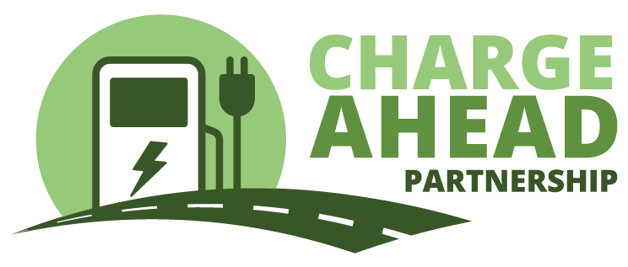Contact: Ryan McKinnon

703-772-0123

May 29, 2024

**New York electric vehicle charging legislation would drive away   
private investment**

**-- SB 749 would give the New York Power Authority near total control of the state’s EV charging marketplace, discouraging outside competition and private investment --**

ALBANY – Legislation that would hand control of New York’s electric vehicle (EV) charging marketplace to the New York Power Authority (NYPA) drew strong condemnation from Charge Ahead Partnership (CAP), a coalition of businesses and organizations working to expand the nation’s EV charging marketplace.

Senate Bill 749 would empower NYPA to build thousands of fast charging stations throughout the state. Specifically, the proposal calls for NYPA to build one fast charger per 5,000 residents, which equals upwards of 4,000 chargers, based on current population numbers. NYPA’s previous EV charging initiatives have relied on millions of dollars from captive ratepayers, the vast majority of whom do not and will never own an EV.

CAP executive director Jay Smith said giving NYPA legislative priority over the private marketplace would drive away private investment, while forcing all power customers – including those who do not own an EV – to pay for NYPA’s charging network.

“Private businesses want to invest their own money in EV charging, but state lawmakers are driving entrepreneurs away from New York with this proposal,” Smith said. “Rather than relying on private dollars, this plan would result in all New Yorkers paying higher power bills and seeing their tax dollars take the place of private investment.”

Similar proposals have faced vigorous bipartisan opposition in Minnesota, Colorado and New Mexico just this year. Allowing a single entity to control the charging market not only harms free-market competitors, it also disproportionately relies on public funds from people on low and fixed incomes, most of whom do not own an EV. As a result, pro-business groups have united with consumer advocates in many states to push back against state control of the EV charging marketplace.

CAP urges New York lawmakers to support legislation that relies on electric utilities to generate and distribute power, while allowing the private marketplace to sell that power to drivers.

“New York needs its power system and private marketplace to work together as partners, not competitors,” Smith said. “New York’s EV charging network will require massive amounts of power, and that should be NYPA’s focus. Allow the private retailers with experience serving drivers to own and operate the EV charging stations.”

*###*

To learn more about **Charge Ahead Partnership (CAP)** and our efforts to help expand America’s EV charging network please visit [**www.chargeaheadpartnership.com**](http://www.chargeaheadpartnership.com/). In addition to joining CAP you can stay connected with us by following us on social media on Twitter at [**@EV_ChargeAhead**](https://twitter.com/EV_ChargeAhead), on LinkedIn at [**@ChargeAheadPartnership**](https://www.linkedin.com/company/charge-ahead-partnership), on Facebook at [**@ChargeAheadPartnership**](https://www.facebook.com/ChargeAheadPartnership) and on Instagram at [**@EVChargeAhead**](https://www.instagram.com/EVChargeAhead/).